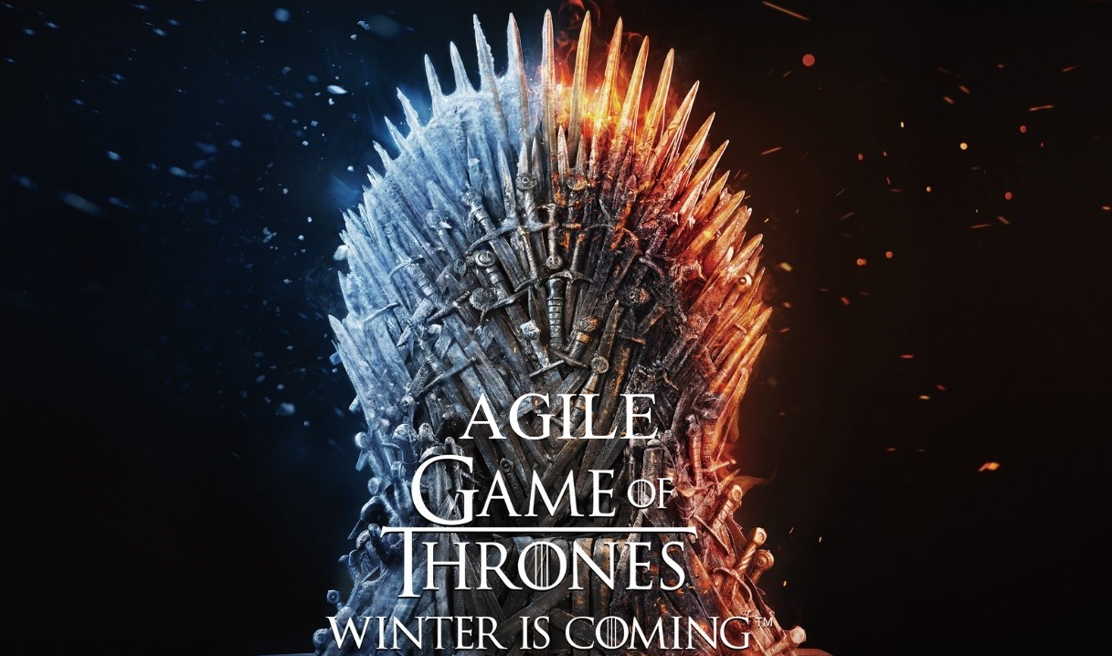

**Fabrication totale : 52 semaines**

|  |  |  |
| --- | --- | --- |
| Bottes (6 sem) | Epaulières (1 sem) | Plastrons (5 sem) |
| Bras (5 sem) | Cape brodée (7 sem) | Gantelets (9 sem) |
| Jambières (7 sem) | Casque (4 sem) | Cotte de mailles (4 sem) |
|  | Fourrure (4 sem) |  |
|  |  |  |

**Episodes (4 semaines/EPiSODES)**

|  |  |  |  |
| --- | --- | --- | --- |
| Episode 1 | Episode 2 | Episode 3 | Episode 4 |
|  |  |  |  |

|  |  |  |  |
| --- | --- | --- | --- |
| Episode 5 | Episode 6 | Episode 7 | Episode 8 |
|  |  |  |  |